Flight Delay Analysis enhancing user experience and Big Data Visualization of delays in the United States

Deepthi Mounica Mandalaparty
Department of Business Administration
California State University, EastBay
Hayward,94542,United States
dmandalaparty@horizoncsueastbay.edu
Fabjola Kasaj
Department of Business Administration
California State University, EastBay
Hayward,94542,United States
fkasaj@horizon.csueastbay.edu

Anjaneya chowdary kamepalli
Department of Business Administration
California State University, EastBay
Hayward,94542,United States
akamepalli2@horizon.csueastbay.edu

Abstract— Air travel has become the essential mode of transport for most people in the United States. Air travel is unquestionably the fastest way to get to the destination, but even on shorter trips planes are often quicker. Travelers are inclined towards air travel though it is costlier when compared to other modes of transport. Airline delay analysis aims to evaluate which factors most likely contribute to airline delays, which can help passengers avoid airlines which are delayed the most and make better flight choices to minimize the delay.
However, the main reason for this bad customer experience and traveler’s frustration for the flight delays is because the travelers don’t have access to the airline performance data while making the flight ticket reservations. Providing graphical user interface dashboards of the airline performance data helps travelers to make the better decisions for their travel and minimize the traveler’s frustration. Frequent airline delays create discomfort, bad customer experience and frustration for the travelers.

This project addresses some of the key issues that airline travelers face during their travel and provides visualization dashboards that help in better planning while making flight reservations and thereby improving the travel experience for them.

The main goal of this project is to provide interactive dashboards for the airline travelers. These interactive dashboards will be useful for the airline travelers for doing better analysis and proper research while doing airline reservations in the United States of America. This proper analysis internally helps the airline travelers to make a smart choice while booking their flight.

Keywords—airline delay, delay prediction, data visualization.

Introduction
The airline industry has grown steadily over the years, approximately 5.5% per year over the past 20 years.[1]

In 2017, a total of 36.8 million flights took off and landed. However, numerous uncertainties could hinder planes from taking off. The flight can be delayed for several hours or even for a whole day. According to the study done by Ball et al. , the estimation of total impact of the cost of delays in the American economy by 32.9 billion dollars. This cost affects the country’s Gross Domestic Product (GDP) indirectly and the passengers and the airlines directly. Buying on-time flight will improve our flight experience. By analysing the impacts of different factors on the delay of airline, it is possible to find out the most optimal situation that an airline departs on time. Moreover, airline delay prediction is widely used by insurance companies that provide flight delay insurance. Therefore analysing the various factors that contribute towards the delays could help the passengers schedule their travel without any hassles.
Recent studies have made attempts to analyse what factors influence airline delay. Zamkova Et al. provided a math model and contingency tables to analyse several factors causing airline delay. However a contingency table is not an efficient way to visualize the data. Henriques et al. applied a multilayer perception method to predict flight delays and the best accuracy is only 85%.Since airline delays count on various factors, it is nearly impossible to come up with a model to perfectly predict the delays. Specifically, there are two major challenges in the airline delay analysis with various factors. On one hand, some variables interrelate with all others. For example two or more inclement weather conditions are usually concomitant. On the other hand, some variables make airline delays unpredictable. For example, even small mistakes by the ground crew may cause flight delays.
This project addresses some of the key issues that airline travellers face during their travel and provides visualization dashboards that help in better planning while making flight reservations and thereby improving the travel experience for them.

METHOD
This section describes our analysis of airline delays for the United States. The whole process of our analysis method is shown in the below figure.
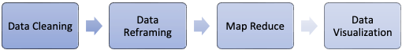
Fig. 1. Flow chart of our analysis method

We first reframe and clean the data collected from January 2010 to December 2020.

Data Pre-processing

1)Data Reframing
The dataset used in this project is extracted from the Bureau of Transportation Statistics (BTS), part of the Department of Transportation (DOT) [2]
It is a huge dataset with 11,221,080 rows and 52 columns. The size of our dataset is 2.7GB.

2)Data Cleaning
Empty data causes inconsistency of the dataset and accuracy varies with different distribution patterns of missing entries [9]. For example, missing data can cause some data to be extremely low or extremely high, which fails the analysis of data trends. Therefore, before working with big data tools such as map reduce, we check on the dataset for missing data. There were a very negligible number of missing values for our dataset and hence data cleaning was very easy and smooth.

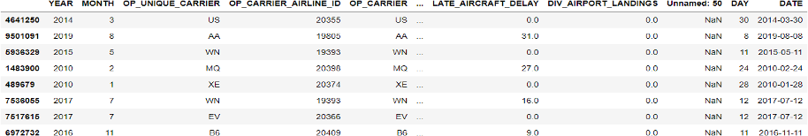
Fig. 2. Dataset sample

Filling Factor: Now it is time to look at our dataset’s filling factor. It means how complete it is. This measurement is based on the percentage of the missing values. In total there are six columns with null values: “Unnamed: Unnamed: 50, DIV_DISTANCE, DIV_ARR_DELAY, DIV_ACTUAL_ELAPSED_TIME, DIV_REACHED_DEST, CANCELLATION_CODE”. The rest of it is complete, with 0% missing values in most of the cases. This is another argument that confirms out path. We need to relay into an accurate dataset to be able to build our analysis and conclusions.

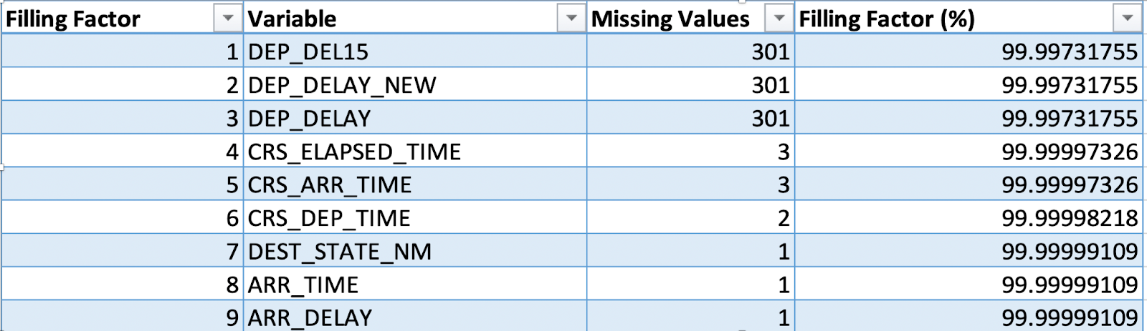Fig. 3. Filling Factor Table

Analysis

1.Basic statistical description of Airlines - ​​It is in the best interest of each company to compete with a better service quality. This can be translated into less delays, low rates, easy procedures and better on boarding service. When it comes to delays themselves, there are many factors affecting. In our dataset we have included carrier delays, weather delays, national air system delays and security delays. As it can be understood, not all the delays are caused by the airlines themselves. There are many other factors that affect, even within these big categories. For example, security delay, can be for any reason out of the company’s control. But when it comes to carrier delays, we cannot say the same. There can be last minute issues, deferrals on maintenance services and other reasons like that that cause those delays. But still in a case like this, from outside, we can judge and blame the company for not being well organized and cautious.

In the figure below we give some simple statistics of the relationship in-between airlines and delays. The only thing to keep in mind is that we are looking only at the departure’s delays. From the graphs we see that Southwest Airlines has the largest percentage of flights, 20%, followed by American Airlines and Delta Airlines.
The average delay at the origin is relatively high since our time frame is 10 years. So, there are a huge number of records. To be able to have a more realistic view of these statistics we should separate our analysis into years. As for now, our analysis leads to an average of 35 ± 33 minutes delay. Hawaiian Airlines is the one with the lowest delays and Allegiant Air is the one with the highest delays. Finally, the figure at the bottom makes a census of all the delays that were measured from 2010 to 2020. This representation gives a feeling on the dispersion of data and puts in perspective the relative homogeneity that appeared in the second pie chart. Indeed, we see that while all mean delays are around 60 minutes, this low value is a consequence of the fact that most flights take off on time. However, we see that occasionally, we can face large delays that can reach a few tens of hours! Again, the wide range of years affect this analysis.

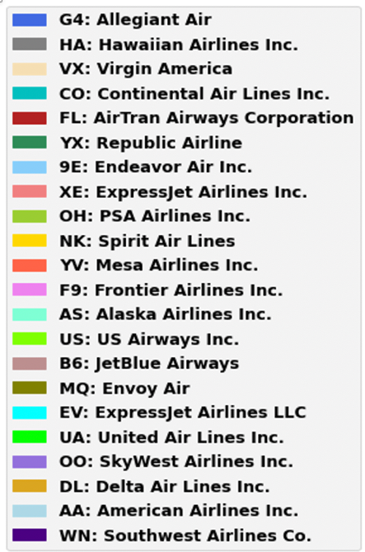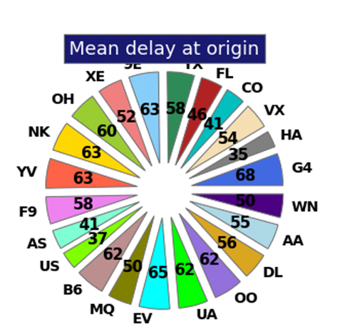

Fig. 4. Mean delays at origin

2.Geographical Area covered by Airlines: When it comes to the origin airport, even just from the rumors, we know that some airports are bigger and more crowded than the others. So, we can guess that based on the airport’s origin the flight's delay should vary.
We will now try to define if there is a correlation between the delays registered and the airport of origin. In total we have 389 different airports in our dataset. Based on that, the graph below shows the distribution of flights every airline company took in those airports.
From this graph we can notice that SkyWest Airlines, ExpressJet Airlines and Endeavor Air are the three companies with the largest flight numbers within the last 10 years.

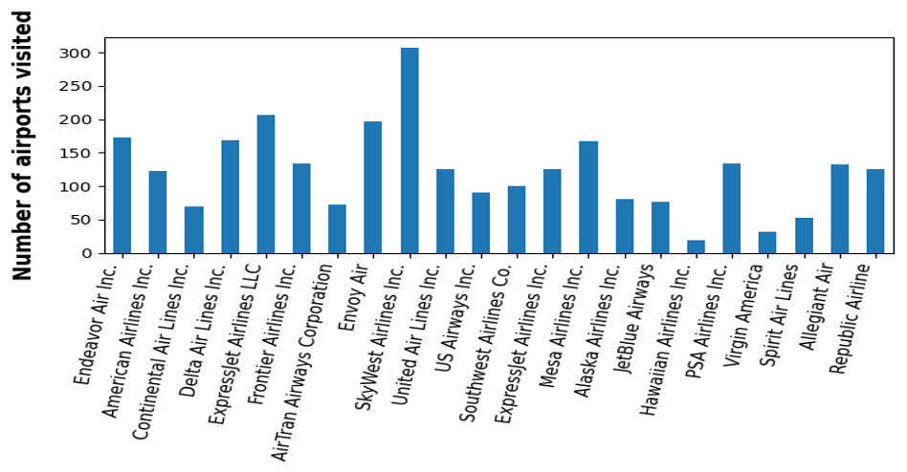

Fig. 5. Number of Airports visited by each Airline

3.Mean Arrival Delay per Carrier: The average arrival and departure delays per carrier is calculated for the whole dataset and we can analyze from the visualization that Hawaiian Airlines has the least average arrival delay of 26.5 minutes for the past 10 years of data when compared to all other airlines.
ExpressJet Airlines has the highest average arrival delay of 61.3 minutes when compared to all other airlines for arrival delays. Almost all the other airlines excluding the above-mentioned airlines have an average arrival delay of approximately 30 minutes.

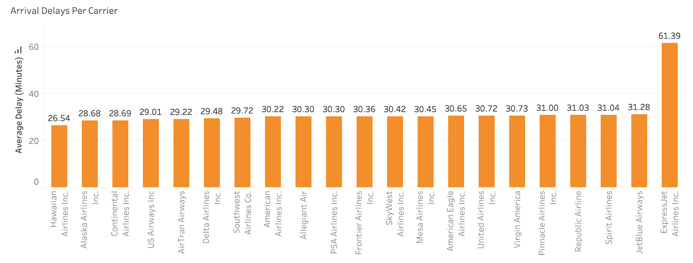

Fig. 6. Average Arrival Delays per carrier Airline

4.Mean Departure Delay per carrier: Hawaiian Airlines has the least average departure delay of 18.10 minutes. ExpressJet Airlines has the highest average departure delay of 48.4 minutes for the past 10 years of data. Almost all the other airlines have an average delay of approximately 20 minutes.

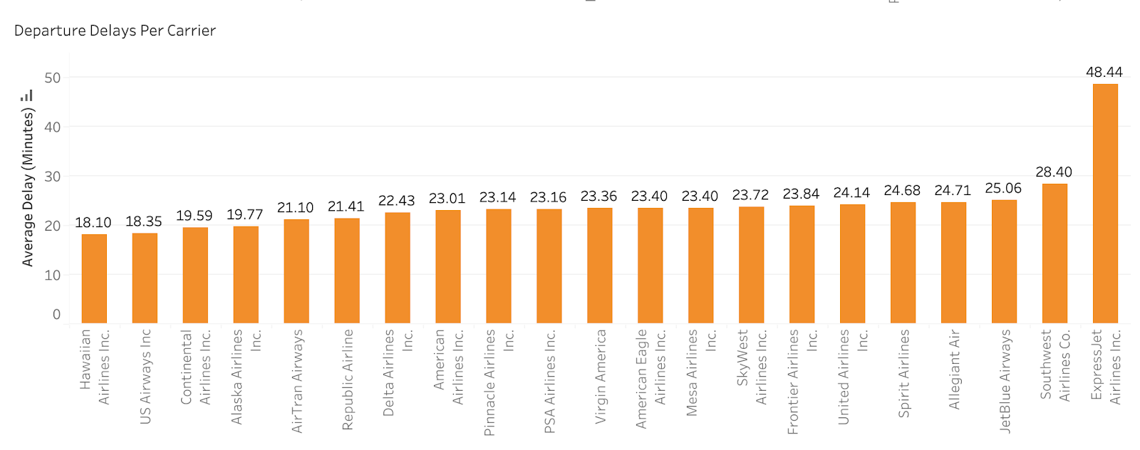
Fig. 7. Average Departure Delays per carrier Airline

5.Monthly Delay Trends: The monthly average arrival delay for July is highest with 64.9 minutes and the monthly average arrival delay for November is the least with an average of 55.9 minutes, compared to all the 12 months. Hence November is the best time to travel, and we can expect delays for sure in the month of July. June, July, and August are the top 3 months with highest delays. November, October, September, and March are the top preferred months to travel with least average delays.

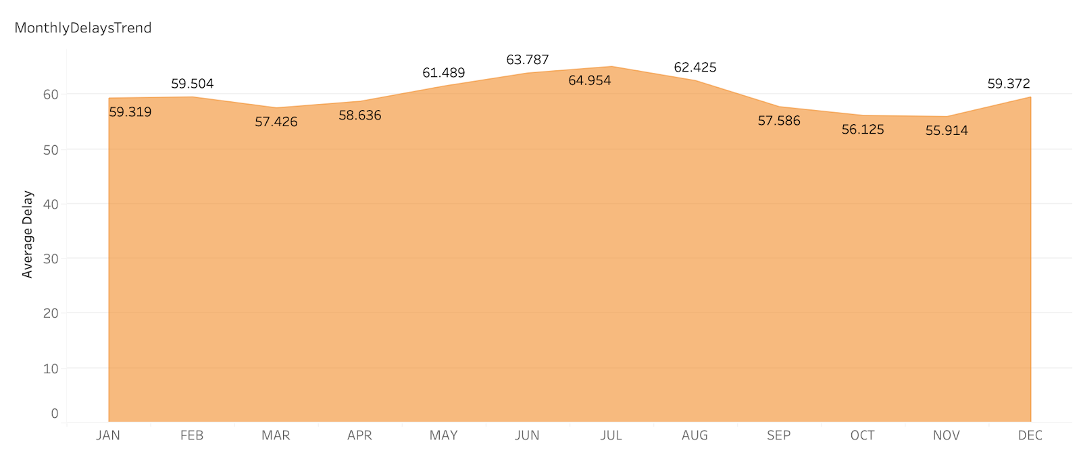
Fig. 8. Monthly Delay Trends

6.Reasons for Delays: The delays in this dataset are divided into 4 categories.

- Air Carrier: The cause of the cancellation or delay was due to circumstances within the airline's control (e.g., maintenance or crew problems, aircraft cleaning, baggage loading, fueling, etc.).

- Weather: Significant meteorological conditions (actual or forecasted) that, in the judgment of the carrier, delays or prevents the operation of a flight such as tornado, blizzard or hurricane.

- National Aviation System (NAS): Delays and cancellations attributable to the national aviation system that refer to a broad set of conditions, such as non-extreme weather conditions, airport operations, heavy traffic volume, and air traffic control.

- Security: Delays or cancellations caused by evacuation of a terminal or concourse, re-boarding of aircraft because of security breach, inoperative screening equipment and/or long lines more than 29 minutes at screening areas.

From our analysis, we found that NAS-delay and carrier delay contribute more towards the delays when compared to all other reasons. The analysis is as below.

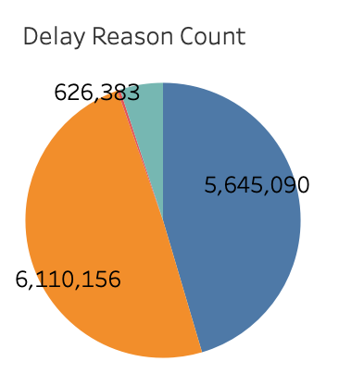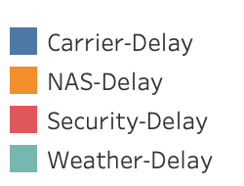

Fig. 9. Delays counts

NAS-Delay contributes more when compared to all the other reasons of delays in the below pie-chart with almost 50% occupancy. Hence it is the most frequent reason for flight delays. Carrier-Delays are the second most frequent reasons for delays. Security-Delays contribute an almost negligible count when compared to all the four reasons for delays.
n
7.NAS Delay Vs Carrier Delay

From the above figure, we can analyze that NAS-delay and carrier delay contribute more towards the delays in airlines. The averages of the NAS delay and carrier delay per airline carrier is calculated in minutes and we can see that the Hawaiian airlines which has the least average delay in both arrival and departure delays has high carrier-delay and spirit airlines has the highest average for the NAS-delay.

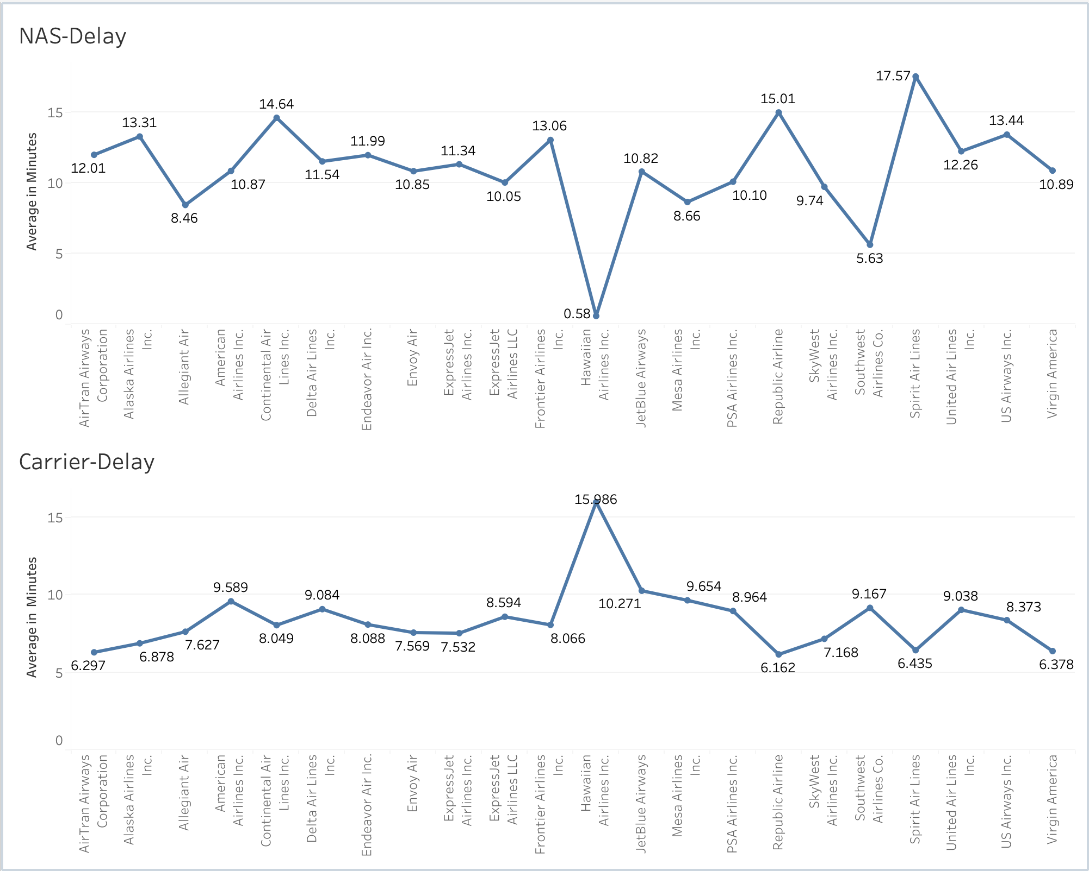
Fig. 10. NAS vs Carrier delays

8.Relation between the origin airport and departure delays

We show a map view of all the states. The ones with darker color get higher delays. We observe that the departure delays vary from 46.17 to 72.87 minutes on average. The states with higher arrival delays are North Dakota, South Dakota, and Kansas. While states with lower arrival delays are Arizona and Utah.

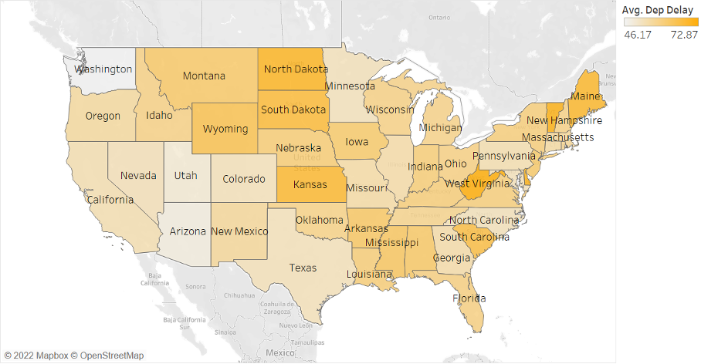

Fig. 11. State Wise Departure Delays

9.Relation between the origin airport and arrival delays

The interval of arrival delays is 51.19 to 82.89 minutes on average. So, arrival delays seem to be longer than the departure ones. The states with higher arrival delays are West Virginia, Kansan and North Dakota.

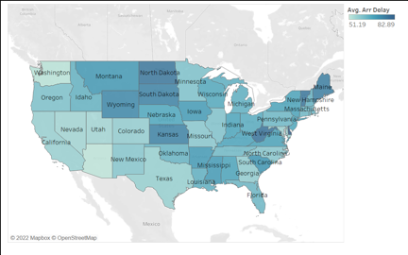

Fig. 12. State wise Arrival Delays

10.Temporal variability of delays

Here we look at the way delays vary with time. Considering the case of a specific airline and airport, delays can be easily represented by year. So, now we do not use year as a filter but as a dimension. Observing the results overall there is a general tendency of having higher arrival delays than departure delays in almost all the cases.

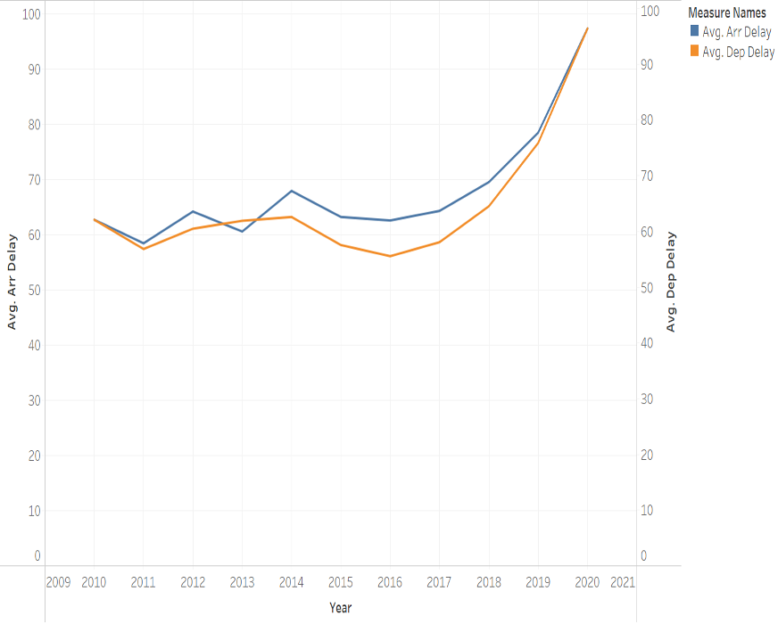

Fig. 13. Change of delays over years

11. Flight DeLay probability Heatmap

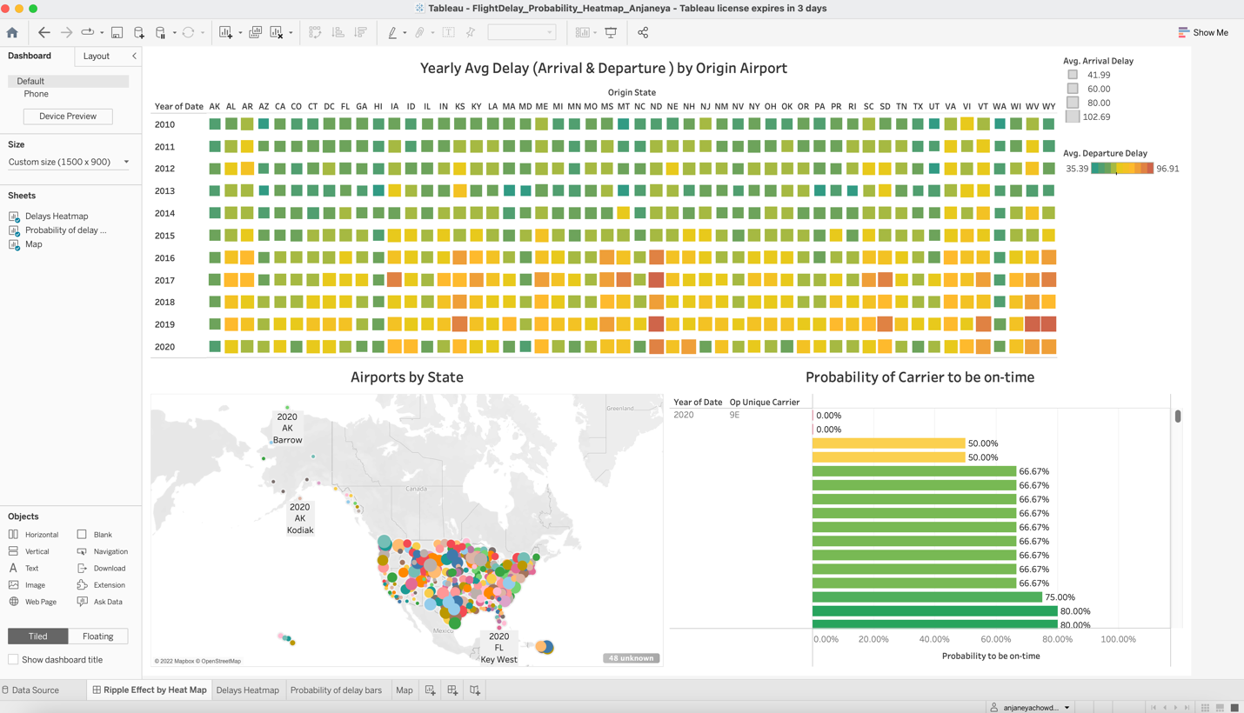

Fig. 14.
The Heatmap shown above crafted by taking the Dimensions ‘origin state’ and Date(year). The size of each square in heatmap depicts the Average arrival delay. Being a small square represents less delayed, and vice versa. Color of each square in heatmap represents the Average Departure delay. Green represents the less delayed, whereas red represents the highest delay.

In order to calculate the Probability of carrier to be on-time, we need to filter data by state wise, and then airport wise. To achieve this in best interactive way, we have designed Multilevel dashboard in Tableau. Hovering the mouse pointer over the heatmap will filter the data for level-2 graph (Airports by State), then user will be presented with the airports available in selected state. By choosing the airport, the probability of different carriers traveling from that airport will appear in bar graph. The color of bar indicates the severity of delay compared to other carriers, whereas length of bar represents the probability Percentage.

12. Flight delay probability by geography

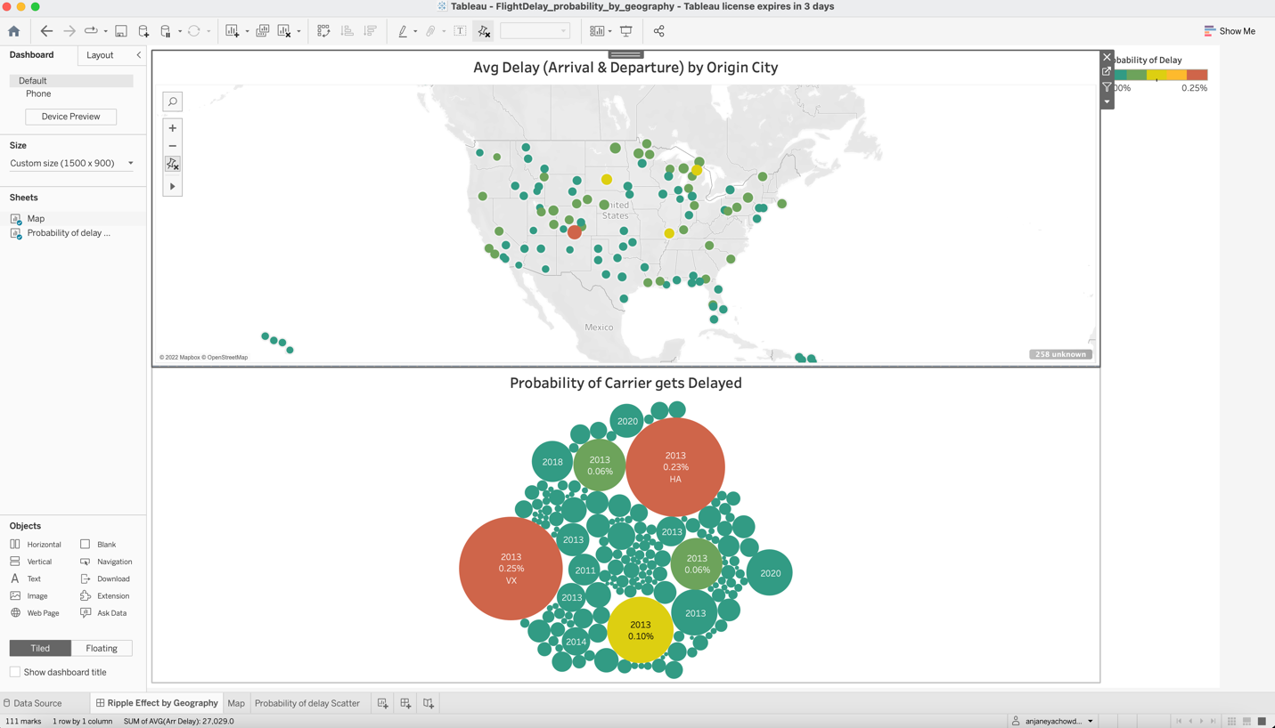

Fig. 15.

The dashboard above is built for the replica of ‘Flight delay probability Heatmap’ dashboard, but by providing different way of user interaction. In the dashboard user is presented with various geographical map of entire US, and data points will show the Airport origin city. By choosing the desired airport, the lower half of dashboard wizard will show the carrier wise delay probability. By this kind of interaction with flight delay analytics, user can quickly get the idea on which carrier will delay most from chosen airport, there by one can make wise choices to avoid predictable delays.

13. Airtime correlation with Distance group

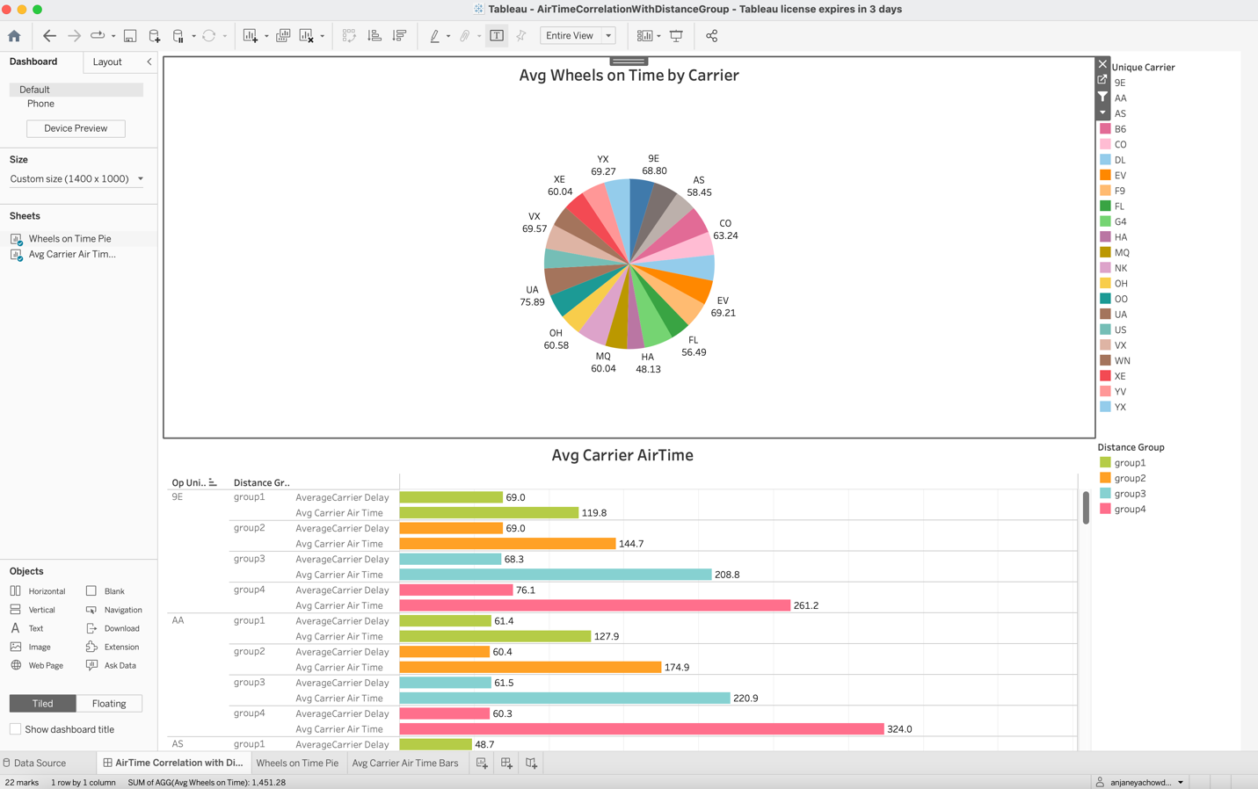

Fig. 16.

As we know Time is inversely proportional to the Distance, Air travel is the fastest means, despite of that distance groups play role in travel times. For our analysis dataset having the distance in the range of 1 – 2500 miles. As mentioned in field definitions, we have divided into 4 distance groups.
The pie chart depicts the Average wheels_ON_Time for each carrier, User have the flexibility to select the sector of pie for selecting the desired carrier, there by one can filter the correlation graphs. To understand the correlation between distance group and delay timings, Airtime, we plotted a horizontal bar graph.
Bar graphs are shown against the Distance Groups, and further classified into to ‘Carrier Delay’ and ‘Airtime’. The labels on bars representing the Average time in Minutes.

We can say that groupwise delay is not varying much among different groups, which is representing that the most of delay happening at arrival and departures but not in the airtime. As distance is increasing, airtime of carrier is increasing proportionally. Correlation results are interesting and useful.

14. Delay prediction by carrier

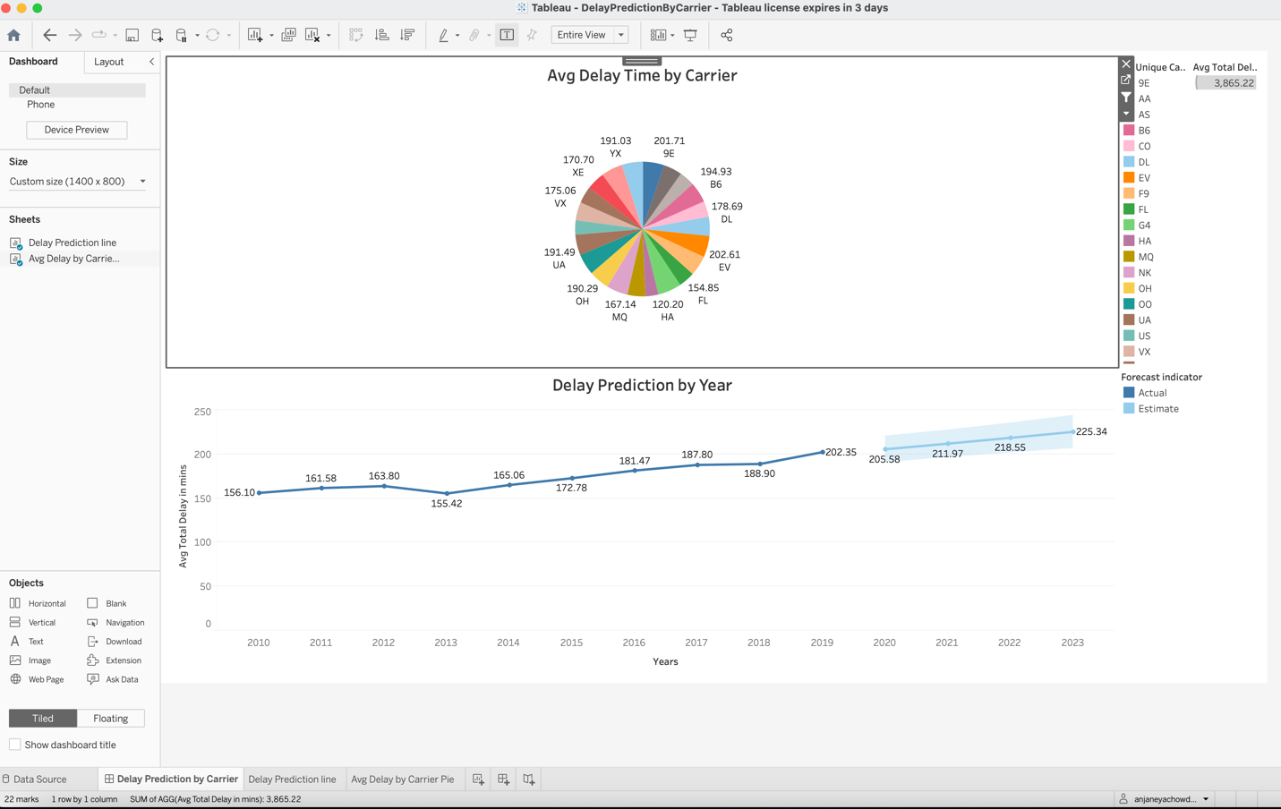

Fig. 17.

The Dashboard ‘Delay prediction by carrier’ is representing the Pie chart with Average delay in minutes for each carrier. By choosing the sector in pie chart for specific carrier, the line chart data gets filtered for only that carrier. Line plot is plotted with average delay time against the different years. For delay forecasting in upcoming years, the line plot is extended in future until 2023. The estimated forecast delay is shown in light color, whereas the range of delay estimation is shown as cloud surround the predicted line (see the dashboard image).

Calculated field definitions
Tableau provides inbuilt functionality to create the custom calculated fields with all kinds of aggregated functions. For creating our analytic dashboards, we have used calculated fields.

- Average Arrival Delay: Arrival delay field is available in dataset; we need to calculate Average of ‘Arrival Delay’ in minutes. While building into Tableau sheets, this calculated field will get aligned as each carrier’s Average Arrival delay in minutes.
- Average Total Delay in minutes: This calculated field is dependent on another calculated field named ‘Total Delay in mins. We need to Calculate the Average of ‘total delay in mins’, in Tableau sheets this calculated field will get aligned for each carrier average ‘Total delay’.
- Number of flight occurrences: To calculate the probability of delay, we need the calculated field for ‘How many times the same carrier has travelled from the same airport in same year?’. To calculate the count of flights from same airport, we have used the Tableau formulae as “﻿SUM (({EXCLUDE YEAR([Date]): (SUM ([Total Delay in mins]))}))”
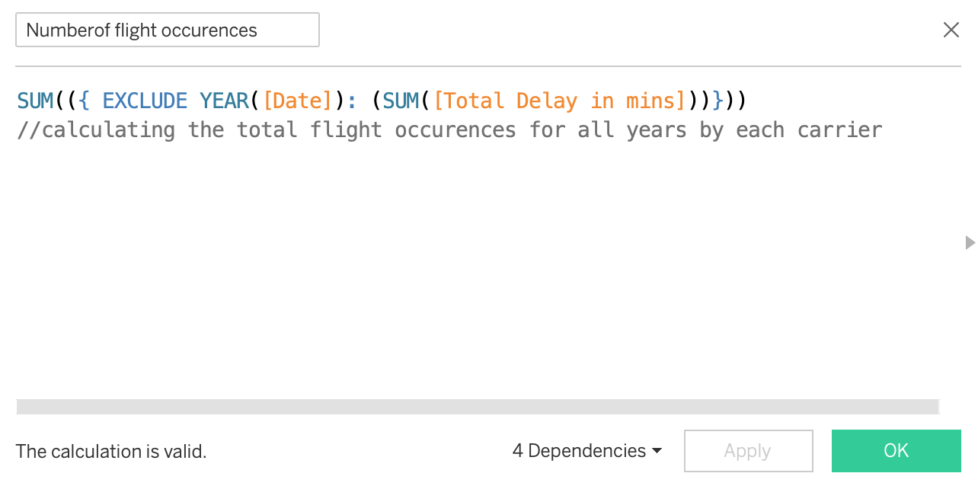
Fig. 18.

- Probability of Delay: The probability of Delay is calculated by Narrowing down data to specific state & year, then calculations as follows:
AVG ([Total Delay in mins])/ [Numberof flight occurrences]

Total Delay in Mins – X
Number of flights occurrences – Y
Probability of Delay – P
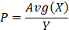

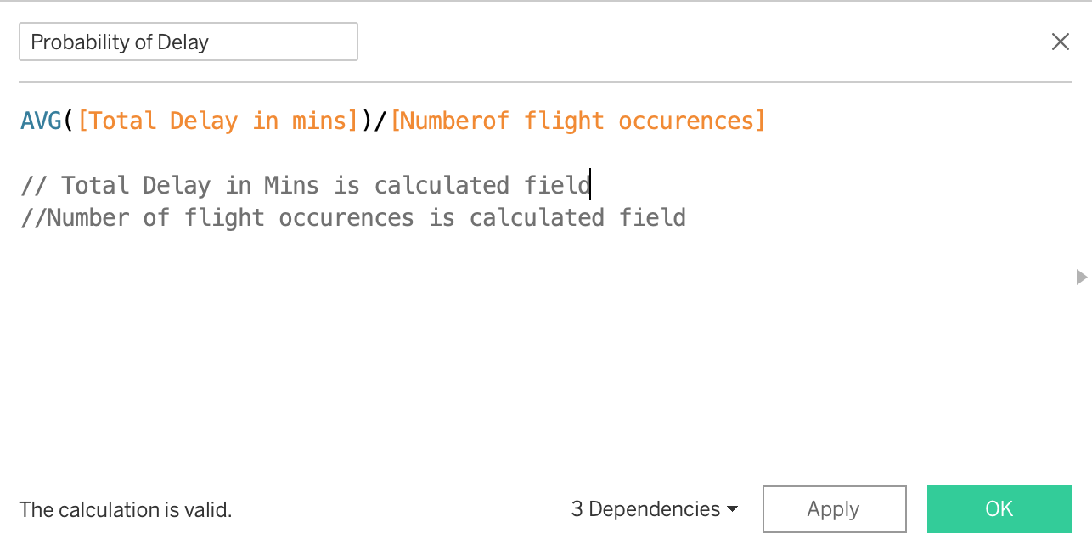
Fig. 19.

- Probability to be on-time: Probability to be on-time is calculated by using the ‘Probability of Delay’
Probability to be on-time = (1 – Probability of Delay)

- Total Delay in minutes: Total_Delay_mins field is calculated by arithmetic sum of all the delays.

﻿Total Delay = [Carrier Delay] + [Late Aircraft Delay] + [Nas Delay] + [Security Delay] + [Weather Delay] + [Departure Delay] + [Arrival Delay]

- Average Carrier Airtime: This field is dependent on calculated field ‘Airtime’
Average Carrier Airtime = ﻿sum([AirTime])/ [carrier count]

- Average wheels on Time: Average wheels on time is calculated by taking arithmetic sum of ‘wheels on Time’ divided by ‘carrier count’
Average_Wheels_ON_time = sum (Wheels_ON_Time) / carrier count

- Carrier count: By using the COUNT function in Tableau we can get the count of carriers.

- Wheels off time: Wheels_OFF_Time can be calculated by subtracting the various ground delays from the Airtime.
Wheels_OFF_Time = ﻿[Airtime]- ([Security Delay] + [Dep Delay] + [Carrier Delay] + [Nas Delay])

- Wheels on time: Wheels_ON_Time is the time elapsed in mins when the carrier is on ground, this can be calculated as sum of delays that can occur on ground.
Wheels on time = [Carrier Delay] + [Nas Delay] + [Security Delay] + [Departure Delay]

- Airtime: Airtime is calculated as the time difference between Departure time and Arrival time. To achieve this in Tableau we have the inbuilt function DATEDIFF.
Airtime =DATEDIFF (‘minute’, [DepTime], [Arr Time]))

Distance Grouping: Sorter distance travels will incur less delays, and longer distance journeys with more stops will incur more delays. In this context, we have divided the range of air travel distance into 4 groups.
Group1: Distance range between (>0 and < 400 miles)
Group2: Distance range between (>400 and < 800 miles)
Group3: Distance range between (>800 and < 1200 miles)
Group4: Distance range between (>1200 and < 2500 miles)

UI Interface:

To provide the graphical user interface to the users, we have used the Angular JS website and built the interactive features. To setup the environment, user needs to install the Node JS Standard version and Angular command level interface. For custom built of site, use the any of the frameworks from the Angular material package.

After setting up the environment, create a UI project, and import the angular material package into the project. Create the HTML scripts for the dashboard design.

Tableau Dashboards need to be uploaded to the Tableau public server, there by generating the Embedded scripts. These scripts are required to include in the HTML pages.

Below Fig depicts the UI project structure and schema of Angular site:
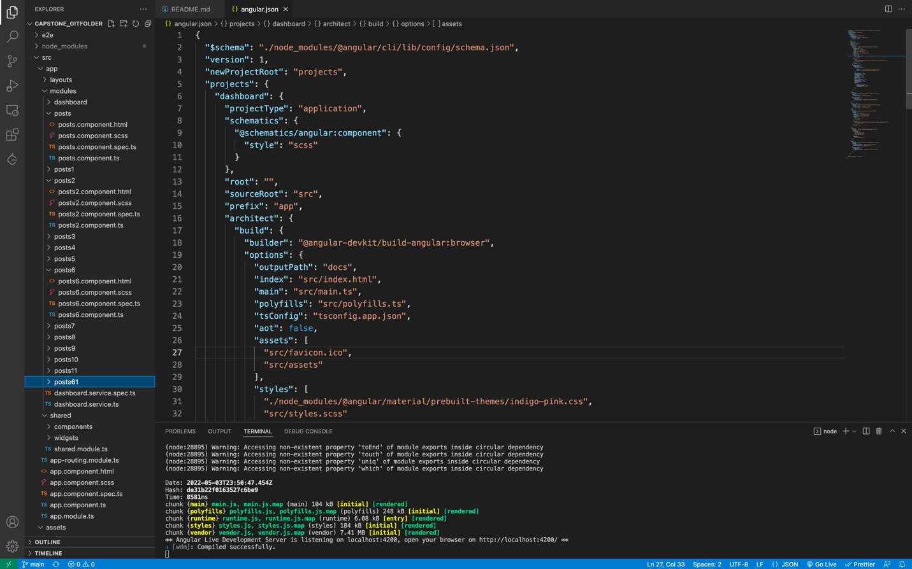
Fig. 20.
Interactive User Interface design is as shown below
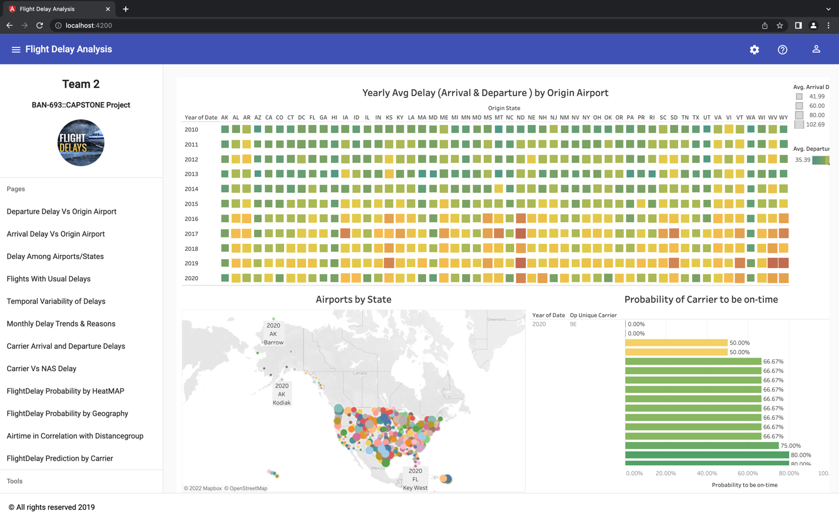
Fig. 21.

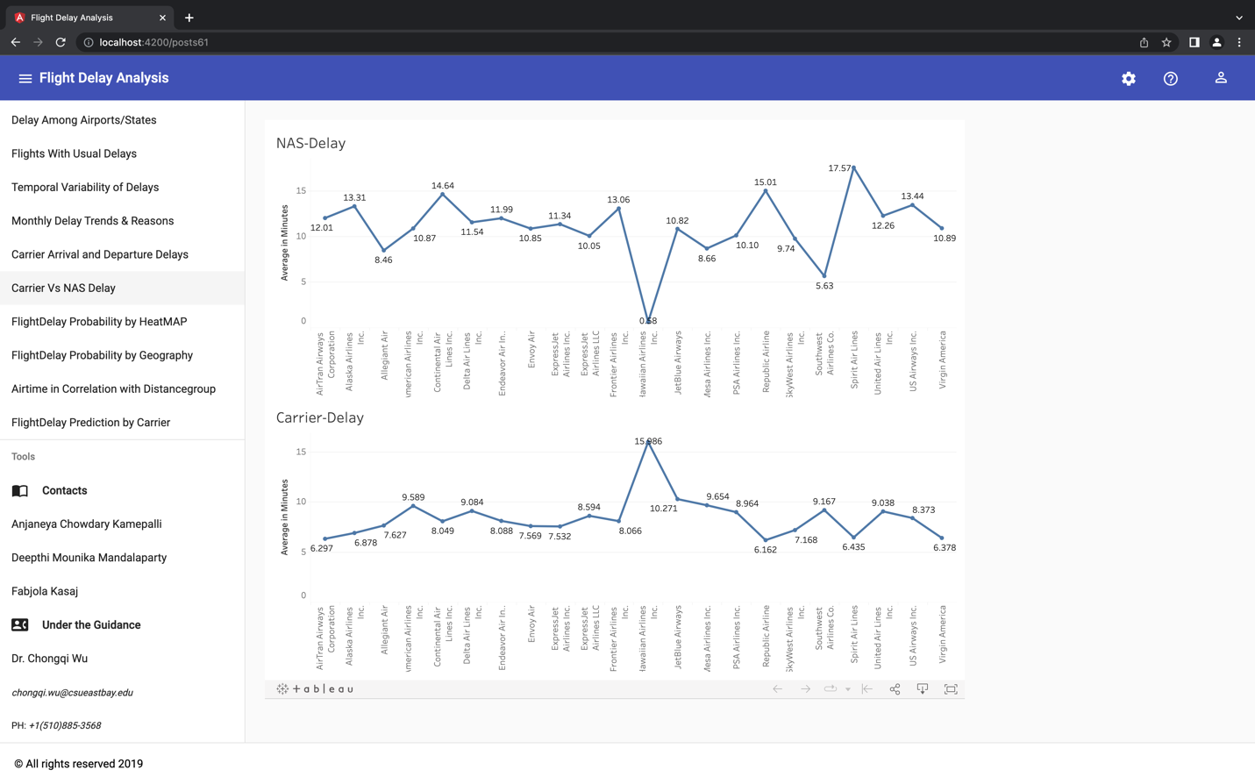
Fig. 22.

For version controlling, we have used GitHub integration. All the project is committed to the main branch.

GitHubURL: https://github.com/DeepthiMounica/FlightDelayAnalysis

Conclusion:

Our Analysis on Flight delays as shown in the graphical interactive interface, user can quickly gain the knowledge about expected delays for desired origin and destination airports for Different carriers, thereby making the wise choice in selecting carrier that have highest probability to be on time. This analysis is available in UI website and made available in Git repository for hosting website up on publishing this paper.

References
[1]https://www.statista.com/statistics/193533/growth-of-global-air-traffic-passenger-demand/

[2]https://www.transtats.bts.gov/OT_Delay/OT_DelayCause1.asp?20=E

Jianmo Ni, Xinyuan Wang, Ziliang Li ”Flight Delay Prediction using Temporal and Geographical Information”, https://cseweb.ucsd.edu/classes/wi17/cse258-a/reports/a032.pdf
- https://www.transtats.bts.gov/
- https://hbswk.hbs.edu/item/improving-fairness-in-flight-delays - Article from Harvard business school.
- https://ui.adsabs.harvard.edu/abs/2019arXiv190306740C/abstract
- https://angular.io/docs - Technical help attained for building user interface.

.

